Parish Report – February 2026
Councillor Nicky Willshere Email: Nicky.Willshere@Midsuffolk.gov.uk
Rattlesden Ward Mobile: 07793610542

Find out how much heat your home is losing – by borrowing a thermal camera for free
Sustainable Suffolk and the Suffolk Climate Change Partnership – which includes Babergh and Mid Suffolk District Councils – have previously loaned out thermal cameras to community groups through their project called Keep the Heat.
The thermal images taken by these community volunteers revealed where heat was escaping from people’s homes and businesses, making buildings cold, increasing energy bills and emitting wasted carbon into the atmosphere.
Equipped with information on how home and building owners can stop the leaks, the Keep the Heat volunteers have helped people to take action to stay warmer, lower their bills and their carbon footprint. Since 2022, over 153 community groups have taken part in Keep the Heat, surveying almost 2,000 homes across Suffolk.
Thanks to the success of Keep the Heat and the desire from residents for more ways to take part, people in Suffolk can now borrow a thermal camera themselves from their local library for free.
This collaboration with Suffolk Community Libraries gives anyone over 18 with a library card the opportunity to take thermal images of their own home.
To take part:
1. Sign up for a library card, if you don’t already have one. Suffolk library cards are free, simply sign up on the website or ask at your local library.
2. If you live in or around Ipswich, you can collect a camera by visiting Ipswich County Library or book a camera online, just as you would reserve a book and it’ll make its way to your local library for you to collect.
3. Take your pictures. The cameras are straightforward to use, and all come with a handy step-by-step guide.
4. Return the camera to the library so someone else can borrow it.
There is no obligation to make your home more energy efficient if you borrow one of the thermal cameras. However, Sustainable Suffolk offer lots of free advice on quick and easy ways to ‘plug’ the leaks that you can do yourself such as draft excluders and thermal curtain linings. They also provide a booklet that highlights grants and support available to Suffolk residents for bigger improvements, such as thicker loft insulation.

There is also additional help for Mid Suffolk residents through the council’s Cosy Home initiative, with funding of up to £5,000 available for eligible homeowners, tenants or landlords.

Future changes to bin collections
From June 2026, households will have more opportunities to recycle as part of nationwide changes to waste collections.
These changes include:

New collection schedule
Households will be provided with four collection services as standard:
- a weekly food waste collection
- a three-weekly refuse (general rubbish) collection
- a three-weekly paper and card collection
- a three-weekly recycling collection for glass, plastics, metal and cartons
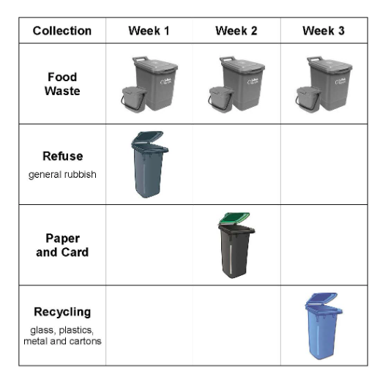
Pre implementation leaflets are being delivered across Suffolk, and every household should receive these in the next few weeks.
During May, households will be sent a detailed information pack and new collection calendar. Please continue to use your bins as you currently do until then, a detailed information pack which will inform you when to start using them from.
Garden waste (brown bin) collections will remain an optional, separate charged for service, with collections continuing fortnightly.
Households will receive two food waste containers:
- one lockable 23 litre food waste bin to leave outside for collection
- one smaller 5 litre caddy for use in the kitchen - small enough to sit on your worktop or under the sink
Most households will also receive one extra 240 litre wheelie bin:
The food waste containers and extra bin will be delivered to households between February to May 2026.
Once you have received them, please store them somewhere safe, and do not use them.

Addresses in Mid Suffolk
- will be delivered a blue lidded recycling bin for glass, plastics, metal and cartons
- the current green lidded bin will become the paper and card bin

